PRACTICAL-4

OBJECTIVE – CREATE AN AWS LAMBDA FUNCTION

**1. Log in to AWS Management Console**

* Go to AWS Console.
* Sign in with your credentials.

**2. Navigate to AWS Lambda**

* In the search bar, type **Lambda**.
* Click on **Lambda** service.

**3. Create a New Lambda Function**

* Click **Create function**.

**4. Choose a Creation Method**

You’ll see 3 options:

1. **Author from scratch** → (most common, start fresh).
2. **Use a blueprint** → predefined templates.
3. **Container image** → deploy code as Docker container.

Select **Author from scratch**.

**5. Configure Basic Settings**

* **Function name**: Enter a unique name (e.g., MyFirstLambda).
* **Runtime**: Choose a runtime (Node.js, Python, Java, Go, etc. → example: **Python 3.9**).
* **Permissions (Execution Role)**:
  + **Create a new role with basic Lambda permissions** (recommended if you’re new).
  + Or choose an existing IAM role if you already have one.

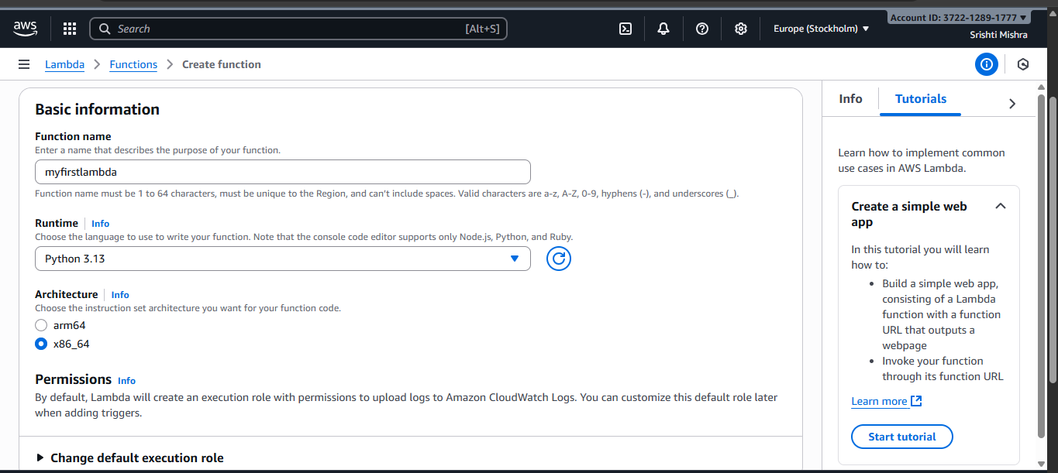

**6. Click Create Function**

* Wait a few seconds while AWS provisions the function.

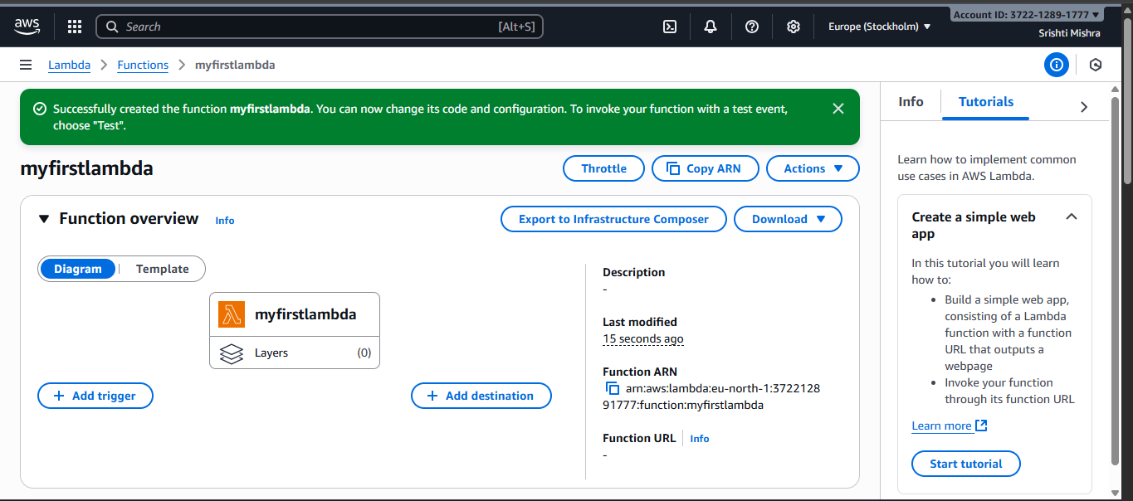

**7. Add Your Code**

* In the **Function code** section, you can:
  + Write inline code in the editor.
  + Or upload a .zip file.
  + Or use **Amazon S3** (if your code is stored there).

Example default code in Python:

def lambda_handler(event, context):

return {

'statusCode': 200,

'body': 'Hello from Lambda!'

}

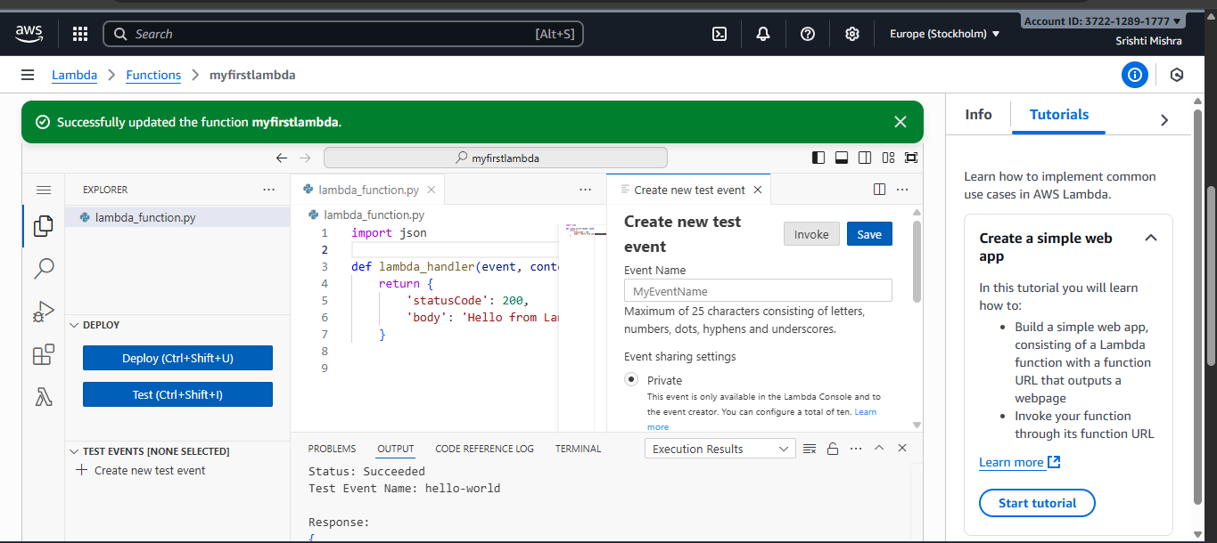

**8. Configure Test Event**

* Click **Test** → **Configure test event**.
* Give it a name (e.g., TestEvent).
* Keep the default event JSON or modify as needed.
* Save.

**9. Run the Function**

* Click **Test** again.
* Check the execution results (output, logs, and status).

**10. (Optional) Add a Trigger**

* You can connect Lambda to services like:
  + API Gateway (for REST APIs)
  + S3 (trigger on file uploads)
  + DynamoDB (trigger on database changes)
  + EventBridge (scheduled events)

